**IFT 466 Advanced Computer Networks**

**Lab 32  
WAN – Setup a Site-to-Site VPN**

After you complete each step, put a ‘√’ or ‘x’ in the completed box

**Objectives**

Configure VPN Site to Site on Cisco Router

**Part 1: Setup and configuration of topology**

1. Setup the following topology

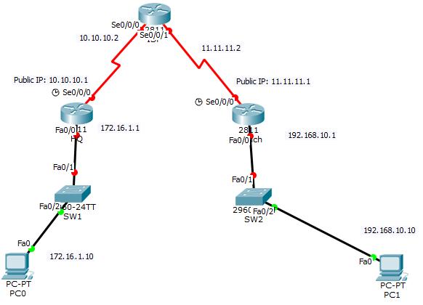



1. Configure IP addresses (as shown on the topology above) to all routers on all ports

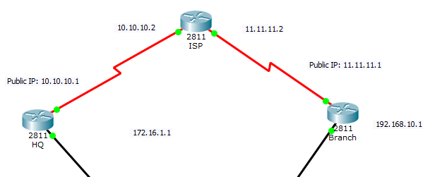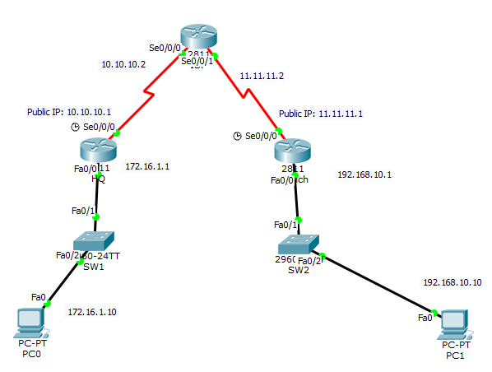



1. Configure default router on HQ and Branch and static router from ISP









1. Now perform a ping from PC0 to PC1



✓

**Part 2: Configure the VLAN (4 steps required and configured below on the HQ and Branch routers)**

1. Configure ISAKMP policy to establish the IKE (Internet Key Exchange) tunnel
2. Define IPsec Transform Set
3. Create Access List
4. Create Crypto map for IPsec

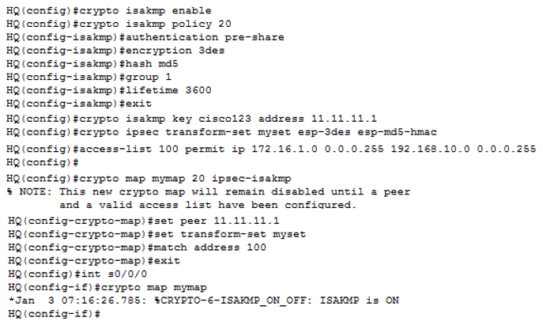

 ✓

Repeat the same commands for the branch route but just change the peer address to be 10.10.10.1

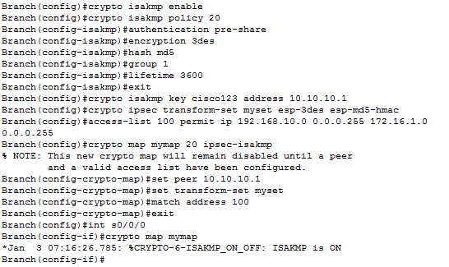

 ✓

Now we can test the VPN

Can you ping from PC0 to PC1?

✓

If you checked “No” then you can not go any further. Check your settings.

**Part 3: Verify the VPN (using 4 show commands)**



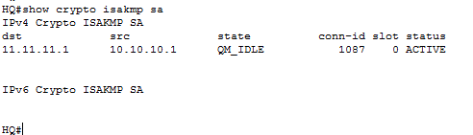



✓



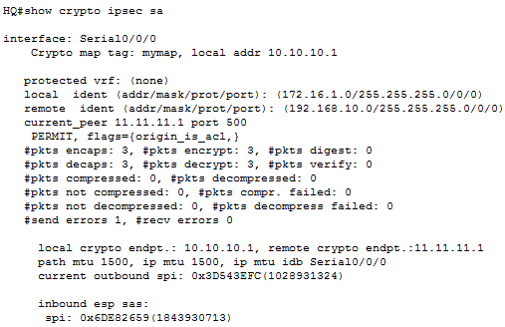

 ✓

Now a ping a couple more times from PC0 to PC1  
  
Number of packets will increase as shown in the image below (now 11 and not 3 as in previous email)

After we re-run the show crypto ipsec sa command

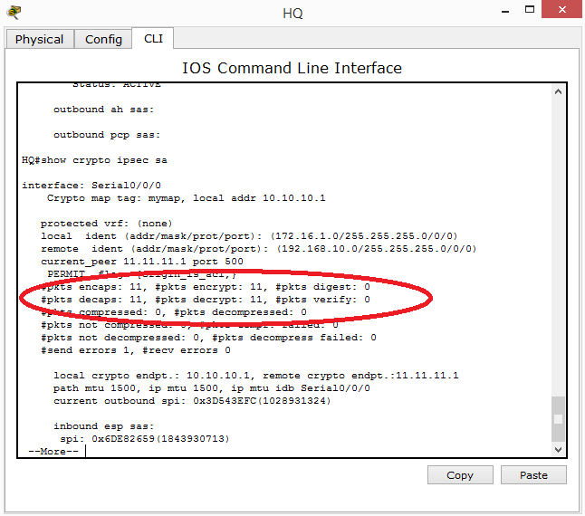

Run the same 2 show command on the branch router



✓

Do you get similar results?



✓

Please say you did, if not, then back you go till you do!

Now run the show crypto may on HQ

****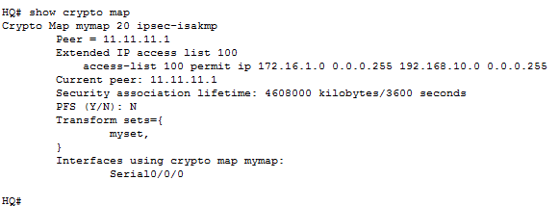

✓

Now run the show crypto isakmp policy command

****

